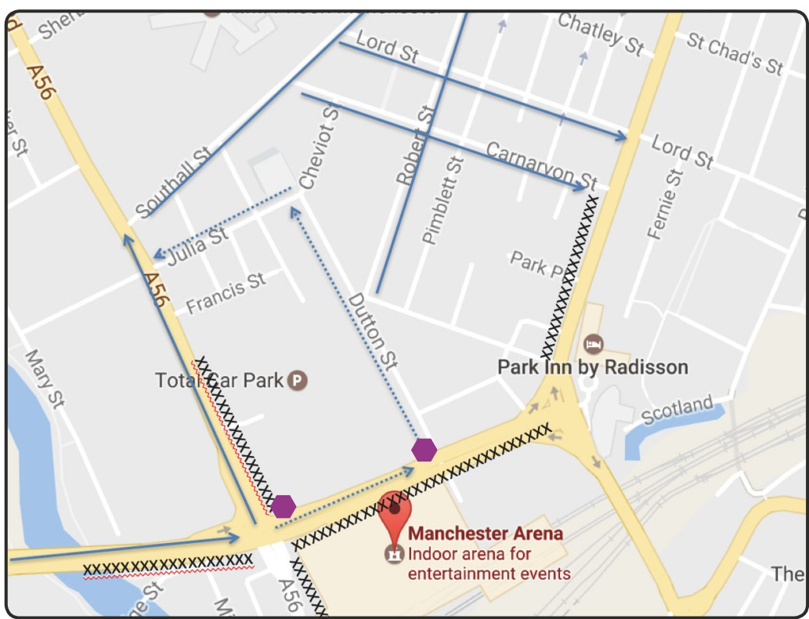
COACH DROP OFF / PICK UP INFORMATION - BLUE ZONE
Important: There is no parking or drop off on NEW BRIDGE STREET, the A56 or Victoria Station. Manchester City Council will be actively enforcing fines on coaches parking in the areas marked by xxxxx on the map.
The BLUE COACH ROUTE arrives eastwards on the A6042 Trinity Way and proceeds onto Bury New Road (Great Ducie St). The dotted lines on the map are a contingency route in case the other area becomes congested, in this event you will be directed to continue onto New Bridge St and left onto Dutton Street and follow the Traffic Stewards direction to the drop off areas.
For disabled and wheelchair access please drop off by the Huntsbank Entrance of the Arena.
Please be aware you will be parked in the general area marked by the Blue Lines, you will still need to be in contact with your driver at the end of the night to find out exactly where your coach is parked. Please advise your coach driver to meet you at the end of the concert on foot at the points marked 1 or 2 on the map below and escort you to where the coach is parked.
Coaches that are staying for the day will need to park at the Etihad Stadium, Ashton New Rd,
Manchester M11 3FF. On returning to the arena for collection please proceed on the A57 Westbound to join Trinity Way, this is to avoid the road closure in place alongside the venue.
IMPORTANT. ALL Teachers MUST have the coach drivers mobile phone number.

2

1

