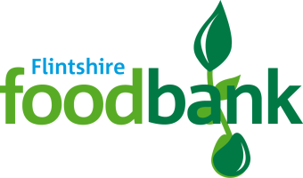

**Harvest Collections for the Local Foodbank**

This year our Harvest collection will support the Flintshire Foodbank. Our local foodbank helps so many local people and is a lifeline for many of our own local families. Thank you for all the amazing donations so far- you have been so generous!

At Westwood we will be collecting for our local Foodbank. The Foodbank welcome all packaged donations but are in URGENT need of

***TINNED/PACKET POTATOES***

***LONG GRAIN RICE***

***TINNED/PACKET CUSTARD***

***TOOTHPASTE***

***SOAP***

***TINNED RICE PUDDING***

If you can make a Harvest donation towards the Foodbank, please send this into school with your child until our closing date on Thursday 21st October. Each class have a box to collect donations safely, which will be collected by the Foodbank. Your donation will make a real difference — no family should ever go hungry.

For more information on the work of the Flintshire foodbank, please go to **https://flintshire.foodbank.org.uk/give-help/donate-food/**