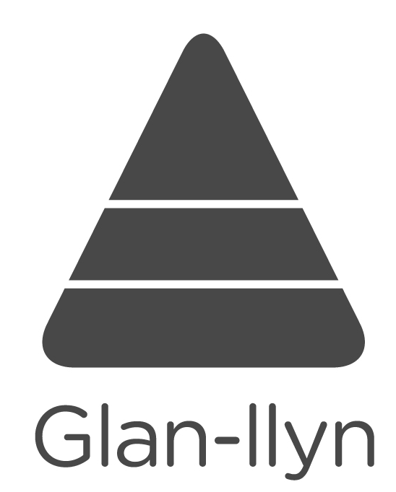
Gwersyll Glan-llyn

Health Certificate

This form should be completed by a parent/person with parental responsibility

Full name……………………………………………………Date of birth…………………..…………. Age…….…………

Address ..………………………………………………………………………………………………………………………..

………………………………………………………………….Postcode …………..…………………………..………….…

School / Group……………………………………………………… Course Dates ……………………………………..…

Name of family doctor …………………………………………………………………………………………………….……

Address of family doctor …………………………………………………………………………………….…………………

Telephone No of family doctor ………………………………….. NHS Card No. …………….……………………………

Date of last anti-tetanus injection ……………………..………………………………………………………………………

Does your son/daughter suffer from any illness/allergy that calls for special attention or diet, e.g. asthma, migraine, epilepsy, diabetes, allergy to penicillin, food additives, animals, plasters, etc.? YES / NO

If YES, please give precise details and treatment (please continue on separate sheet if necessary) …………………

………………………………………………………………………………………………………………………………………

Please note any recent illness/treatment, within last 3 months ……………………………………………………….

Sometimes a resident requires some ‘simple’ treatment/medication, e.g. a plaster, paracetamol, savlon, insect/wasp bites, sunburn. Do you give a full time member of the Urdd staff the authority to give your child ‘simple’ treatment? YES / NO

It sometimes happens that urgent medical treatment becomes necessary during the time spent at the centre. If such treatment becomes necessary the Director will make every effort to contact the parents so that they can give their consent to whatever treatment may be needed. Occasionally, however, the parents are away and the treatment may be urgent. If this should happen, or if there is no time to contact the parents within reasonable time for one reason or another, parents are asked to authorise the Director to act in their absence and to give consent to whatever treatment may be necessary, if in the opinion of the doctor or surgeon concerned any further delay is likely to endanger the child’s health and safety. Even then, it is understood that he will only act in a case of emergency. If you agree to this you are asked to sign the following authorisation.

Should any urgent medical treatment be necessary in the case of my son/daughter…………………………………. while at the centre, and should contact with parents not be possible within reasonable time, the Director is hereby authorised to give permission for the necessary treatment.

Having read the enclosed information sheet I am happy for my son/daughter to visit the Urdd Centre at Glan-llyn.

Signature of Parent or person with parental responsibility ……………………………………………………….....

Relationship to child ………………………………………………………………………………….…………………….….

Tel. No. Day and Night …………………………………………………………………………………………….……….…

Mobile Tel. No. ……………………………………….……… E-mail ……………………………………………………….

Alternative name and telephone number to be contacted in an emergency e.g. if you intend going away while son/daughter is at Glan-llyn, and the relationship, e.g. grandparents, aunt, friend of the family, etc.

…………………………………………………………………………………………………………………………………..…

This certificate must be brought to the centre. It should not be sent in advance.

If the child is interested in receiving further information about courses at Glan-llyn, please give email address here:

……………………………………………….

Gwersyll Glan-llyn, Llanuwchllyn, Y Bala, Gwynedd, LL23 7ST
Ffôn: 01678 541 000 Ffacs: 01678 541 001 glanllyn@urdd.org www.urdd.org/glanllyn
GWERSYLL YR URDD, GLAN-LLYN
INFORMATION FOR PARENTS

Annwyl Riant / Dear Parent
We look forward to welcoming your child to the Urdd Centre at Glan-llyn. This leaflet gives information on what will be needed for your child’s stay.

Urdd Gobaith Cymru, a registered educational charity, owns Glan-llyn. On arrival your child will be allocated a room that varies in size. We shall ensure that your child shares a room with friends from the same school/adran/aelwyd/area. One of the managers will welcome everybody and explain the rules and regulations, thus ensuring a happy and successful course for all involved.

The following are stressed amongst the rules and regulations –
- to stay clear of the lake and other activity areas at all times apart from specific activity sessions
- to keep within the boundaries of the centre
- your child is responsible for keeping the centre and their room tidy and to respect the centre’s property and other peoples’ property
- to stay away from sleeping quarters, corridors, study rooms and other areas which are not theirs
- fire regulations
- meal times, any special diet arrangements
- the routine during the day and night if someone is ill or has a problem
- the importance of personal hygiene
- location of the drying room
- activities procedures
- that graffiti is not acceptable at Glan-llyn, with a financial penalty imposed for fresh graffiti.
- that Glan-llyn is a non-smoking site

Safety Standards
Customers participating in courses / activities must expect to be involved in adventurous and sometimes strenuous outdoor activities, and customers must ensure that course activities are within his / her own personal capabilities. Gwersyll yr Urdd Glan-llyn is registered with Adventure Activities Licensing Service and licensed to

provide specified activities. License details can be confirmed by calling AALS 029 2075 5715. All our procedures are reviewed regularly, and all equipment checked constantly. All staff has First Aid qualifications.

Guidelines
We have strict guidelines and policies for every aspect of the Centre’s work and activities. Copies are available on our website.

Health Certificate
It is essential that your child brings a completed health certificate with him/her to the Centre. Any current illnesses, problems or special requirements should be noted on this certificate. Please ensure that your child visits the main office at the Centre should any problems arise so that the matter can be dealt with immediately. Any injury or illness that may occur between the time of the medical declaration and the course date must be reported to the centre. Glan-llyn reserves the right to refuse a booking on medical grounds if we believe that the medical condition / illness will be detrimental to the safety of our staff and others attending a course or residential stay.

The Programme
Glan-llyn offers a varied and full programme of activities. Naturally, the activities offered depend on the nature of the course. The course co-ordinator in conjunction with the Centre managers decides on the programme. The centre has a supply of adequate equipment and clothing for all activities. Photographs are occasionally taken of the activities and used for promotional and marketing purposes.

Bad Weather
Bad weather can affect some activities. The decision to change the programme on the basis of safety may be taken.

Your child should bring
- a sleeping bag & pillow case
- night clothes, toiletries, towels
- spare clothes, not expensive clothes
- swimming costume and adequate clothing for lake activities – not jeans
- training shoes, plus an old pair for water activities
- on language and educational courses – a pencil and notebook
On specialist outdoor courses, you will receive further details. On fieldwork courses you should also bring –
- wellingtons and walking boots
Please ensure that your child’s name is on all clothing and equipment.

Your Child should not bring
- MP3 or ipod
- knives
- felt-tip pens
- video games, expensive items
- chewing gum, aerosols – deodorants
- tobacco, alcohol or any unprescribed drug (medications on prescriptions should be noted on the health certificate)
Mobile Phones
Mobile phones are only allowed with the permission of the course leader. Access to the office telephone is available at any time during the course.

Telephone Office: 01678 541 000

Valuables
Everybody will have the opportunity to leave expensive items, e.g. a camera, in the main office; all items may be collected when required.

Meals
There are four meals a day at Glan-llyn and a separate menu is provided for vegetarians. Should your child have any special requirements, please mention them on the health certificate.

Shop
The Centre’s shop sells sweets, drinks and Gwersyll souvenirs.The shop is open in accordance with the wishes of the course co-ordinator. We also have machines, which serve cold drinks and confectionery all day, and which take small change.

The staff
Professional staff administer Glan-llyn and full time staff members supervise the activities, in addition to seasonal instructors who are employed during specific periods.

Refunds
No deposits are refunded apart on medical grounds only. A doctor’s certificate must be submitted for a refund of 50%. After the commencement of the course no deposit is refunded; 50% of the remainder is refunded on medical grounds only on the basis of days lost.

Insurance
The Urdd has Public Liability insurance of £25 million to cover any negligence on our part. No personal insurance is included in the price. Should parents want a policy to cover personal accident, illness, lost property, etc. they should make their own arrangements.

We look forward to welcoming your child to Glan-llyn. Over 12,500 young people stay at the centre annually and we are proud of our care and what we offer. We are sure your child will enjoy and profit form the experience of a residential stay.

If you have any further enquiries regarding the Gwersyll or any problem that arose from your child’s stay, please contact us immediately. More information on Gwesryll Glan-llyn is available on our website.

Hwyl
Staff Glan-llyn

Gwersyll Glan-llyn, Llanuwchllyn, Y Bala, Gwynedd, LL23 7ST

Phone: 01678 541000 Fax: 01678 541 001
glan-llyn@urdd.org www.urdd.org/glanllyn

